Region of Waterloo

Community Services
Housing Services
To: Chair Elizabeth Clarke and Members of the Community Services Committee
Date: November 5, 2019 File Code: S13-40
Subject: Waterloo Region Housing Master Plan (2020-2040)

Recommendation:
That the Regional Municipality of Waterloo take the following actions, as outlined in Report CSD-HOU-19-18, dated November 5, 2019, regarding the Waterloo Region Housing (WRH) Master Plan (2020-2040):
- Approve the WRH Master Plan (2020-2040) (see Attachment 1), subject to annual budget approval;
- Direct staff to include the proposed WRH revitalization strategy at an estimated capital cost of $247 million ($ 2019) in the preliminary 2020-2029 Housing Services Capital Program; and,
- Direct staff to develop a budget issue paper for additional staff positions to be considered through the 2020 budget process to implement the WRH revitalization strategy.

Summary:
This report seeks approval of the WRH Master Plan from Regional Council. The full report has been provided in Attachment 1. The proposed WRH Master Plan serves as a framework for the operations and management of the WRH housing stock. The plan maps out a 20-year timeline to 1) create at least 600 new WRH units over approximately the next 10 years; 2) maintain and operate the current stock of WRH units in a state of good repair; and 3) explore potential divestment options and partnerships as opportunities become available to the Region.
The WRH Master Plan Steering Committee (hereafter referred to as the Steering Committee) recommends that the role of WRH should be to continue as a community housing provider; to create at least 600 new WRH units on the current 65 sites and not include the acquisition of additional property; and maintain the same proportion of subsidized community housing that currently exists (approximately 30 per cent of the total community housing in Waterloo region).
Additionally, the Steering Committee is proposing a WRH revitalization strategy, as part of the WRH Master Plan. This strategy is estimated to be 11-years in duration (2020-2031) to develop 638 additional community housing units on five existing WRH sites in Cambridge, Kitchener, and Waterloo. The recommended revitalization plan includes an estimated total capital cost of $247M ($ 2019) over the 11-year life of this strategy. The proposed funding sources include approximately 20 per cent funding through National Housing Strategy grants ($50M) and the remaining through CMHC mortgages ($99M) and Regional long-term borrowing ($98M). Staff is projecting that at strategy completion in 2030, the annualized tax levy impact will be $3.4M.

Report:

1.0 The Region as a Service Manager
The Region performs two major roles in relation to affordable housing, as Service Manager and as landlord of 2,814 community housing units.
The Region is the Service Manager in Waterloo region, as designated by the Province, and is responsible for program planning, service delivery, resource distribution, compliance, quality assurance, and needs and demand analyses including data and trending in the areas of housing and homelessness. As Service Manager, the Region:
- Oversees 8,991 units of community housing, of which 5,882 units are legislated to be rent-geared-to-income (RGI) units. This level of RGI units must be maintained, per Provincial legislation (the Service Level Standard);
- Provides funding to non-profit, cooperative, and for-profit developers to create new affordable housing stock. Moreover, the Region works with all levels of government to explore the access and use of surplus lands to create more affordable housing through non-profit and/or private sector developers;
- Partners with landlords through its rent assistance (RA) programs which are often time limited (Provincial funded programs with sunset clauses) and contingent on the availability of the affordable rental stock and willing partners. The Region cannot allocate additional RA to units with RGI, per Provincial regulations; and,
- Coordinates access to community housing through a centralized waiting list. As of October 2019, there are 4,798 households on the community housing waiting list, an additional 209 pending applications that are under assessment, and 2,033 applications awaiting assessment. The total number of households who are seeking community housing in Waterloo region is 7,031.

2.0 The Region as a community housing provider
Concurrent to being Service Manager, the Region is a community housing provider, known as WRH, operating and managing 2,814 community housing units across 65 sites. This represents approximately 30 per cent of the total 8,991 community housing units across Waterloo region, making the WRH the largest community housing provider in Waterloo region.

3.0 Proposed WRH Master Plan and relationship to the 10 Year Housing and Homelessness Plan
In February 2017, Regional Council approved the development of a WRH Master Plan and the establishment of a respective Steering Committee (CSD-HOU-17-04). The Plan provides a vision and long-term strategy for WRH for the next 20 years, with a focus on the Region’s role as a community housing provider. As a provider, WRH is presenting a strategy to revitalize, maintain, and potentially divest WRH properties.
The proposed WRH Master Plan is available at www.regionofwaterloo.ca/en/living-here/housing-planning-and-research.aspx#WRHmasterplan.
The proposed WRH Master Plan complements the Region’s 10-Year Housing and Homelessness Plan (2014-2024). The 10-Year Plan broadly guides the Service Manager in service planning and delivery across the housing and homelessness sector, setting strategic directions, targets, and actions to increase housing affordability and expand supports to help people find and maintain housing.
The WRH Master plan directly responds to the 10-Year Plan’s action 1.1 to develop and implement a WRH Master Plan; strategic direction 1 to create more affordable and community housing; strategic direction 2 to retain and maintain the existing affordable housing stock; and strategic direction 3 to facilitate the development of an appropriate range of housing options for various community needs.

3.1 Governance
In February 2017, staff formed the Steering Committee, including Regional Council representatives from urban and rural communities in Waterloo region (currently includes E. Clarke, D. Jaworsky, K. Kiefer, G. Lorentz, and J. Nowak), and senior staff representing various Regional divisions and departments. In addition, staff formed a multi-disciplinary internal team and the Corporate Advisory Committee to oversee development of the WRH Master Plan.
3.2 WRH Strategic Directions
In May 2017, staff retained a consulting team to conduct a comprehensive community consultation process and prepare a summary report of the results (CSD-HOU-18-06).
Based on that feedback, the Steering Committee is recommending that:
- The Region should continue to play a major role as a community housing provider via WRH and maintain the same proportionality of community housing that it currently has (approximately 30 per cent in Waterloo region). By continuing as a leader in high-quality community housing, the Region will have an ongoing influence on the overall level of quality of community housing stock throughout Waterloo region;
- The Region create at least 600 new WRH units within the current 65 community sites over the next 10 years (approximately). This ensures the 30 per cent proportionality, listed above, and that the Region continues to play a leading role in ensuring that 5% of all housing in Waterloo region be affordable; and,
- Given the opportunities on owned property, the Region should revitalize and intensify WRH existing sites to avoid the additional costs of land acquisition. Land acquisition is a barrier faced by all housing providers (cost and availability), but as a housing provider with 65 existing sites, WRH is well positioned to create additional Community housing. The proposed revitalization on existing WRH property is more cost effective and less disruptive to the existing tenant populations than other models. In any future consideration of intensification, maintaining WRH’s RGI amount is required by legislation, complicating the option for future private-public partnerships on these sites. Options for future private-public partnerships would continue to be explored through the Service Manager role or divestment opportunities that are availed to WRH.

3.3 WRH site assessments
The Steering Committee developed three strategic categories, based on the feedback from the community consultation. Each of the 65 WRH sites was assessed using a series of evaluation tools, including an evaluation matrix (focusing on optimizing land use, positive community impacts, current building site conditions, financial implications, and the potential for redevelopment); a financial cost tool; a building site summary synopsis; and an estimated construction schedule. Based on the evaluations, each site was prioritized into one of the three strategic categories:
- Revitalize: Build more affordable housing units by redeveloping and intensifying existing WRH sites. Existing WRH sites have sufficient available property to meet the WRH Master Plan goals, without the need to purchase new lands or expand the number of communities sites beyond a total of 65;
- Maintain: Propose no change in the scale or scope of operations. WRH will continue its current community building programs to improve tenants’ quality of life and access to services and programs. This includes all capital and maintenance programs, building condition assessments, and costs associated with providing 2,814 community housing units; and,
- Potentially divest: Use a decision-making framework to review potential divestment options, as opportunities become available to the Region. Should any WRH site(s) be identified for potential divestment, staff will engage in an ongoing process to involve tenants and the broader community, prior to confirming divestment. If divestment is deemed appropriate, existing tenants will be provided with advanced notice of timelines and offered the opportunity to relocate to other available WRH sites. No existing tenants will be left without housing options.
These opportunities may also include private-public partnerships where divestment is an effective use of the asset. Further, as Service Manager, the Region will also explore the possibility of private-public partnerships on existing Regional surplus lands, to expand the stock of community housing offered by other housing providers. The Steering Committee completed a comprehensive environmental scan of municipalities that have developed affordable housing through private-public partnerships. Private-public partnerships often render a lower upfront development cost but also require more communities/buildings to be redeveloped to achieve affordable housing net gains. It would take more communities and impact more tenants through this model, which potentially offsets the lower upfront development costs.

3.4 WRH revitalization strategy
The Steering Committee designed the WRH revitalization strategy to coordinate revitalization of the sites with the most potential for redevelopment, based on the findings of the 65 WRH site assessments. In preparing this strategy, the Steering committee assessed a total of five potential strategies. This strategy was selected as each site has a relatively high community housing waiting list, which would be reduced via revitalization. It was further acknowledged that there are several existing and brokered services available to these sites (examples vary per site, including support workers, seniors’ services, child and youth services, youth programs), which can be expanded as part of the revitalization through community-based needs. This combination of proposed sites also ensures affordable units are developed on the central transit corridor and meet the needs of each of the three cities, based on the consultation feedback.
Figure 1: WRH revitalization strategy project sites
Address | Total Number of Proposed Units | Current Units per Site | Increase in Units
416 Kingscourt Dr., Waterloo | 70 | 0 | 70
82 Wilson Ave., Kitchener | 48 | 16 | 32
15-105 Mooregate Cr., Kitchener | 476 | 55 | 421
140 Weber St., Kitchener | 54 | 35 | 19
581-595 Langs Dr., Cambridge | 134 | 38 | 96
Total: | 782 | 144 | 638

3.5 The WRH revitalization strategy team
If the WRH Master Plan is approved by Regional Council, staff will submit requests for required additional FTEs through the regular budget issue paper process, in order to form a team responsible for overseeing the WRH revitalization strategy. The team is proposed to comprise of the following positions (see section 6.2.2 in Attachment 1):
- One (1) Community Revitalization Specialist in WRH to communicate and consult with tenants regarding development, and coordinate tenant move-ins and relocation, where required;
- One (1) Planner/Coordinator in Housing Services to obtain planning approvals for each site project; complete funding applications; and coordinate the delivery of the WRH Master Plan; and,
- Two (2) Revitalization staff in Facilities Management to manage proposed projects; lead procurement; administer contracts with consultants; assess designs; and oversee the capital program.
Thereafter, as the new 638 units are incrementally completed, WRH will require seven permanent FTEs. This level of staffing required is calculated based on an average per unit ratio of operational need. It is anticipated that 3.5 FTEs in 2025 and 3.5 FTEs in 2030 will be needed to support the operation and management of the additional units. These positions will be funded through the property tax levy operating budget in Facilities and WRH:
- One (1) Chief Building Officer in Facilities Management to assess and coordinate all ongoing maintenance needs, where required;
- One (1) General Maintenance Specialist in Facilities Management to complete repairs;
- One (1) Maintenance Plumber/HVAC in Facilities Management to address ongoing plumbing and heating needs, where required;
- One (1) Associate Property Management in Facilities Management to review onsite contractor projects, where required;
- One (1) Tenancy Support Specialist in WRH to manage all tenancy related matters, where required;
- One (1) Tenancy Service Coordinator in WRH to complete recalculations, arrears reports, and vacancy management; and,
- One (1) Community Engagement Specialist in WRH to support each new community with community development programs and support services.

4.0 Next Steps
If the WRH Master Plan is approved by Regional Council, the Community Advisory Committee and the Steering Committee will each remain intact to continue to provide oversight and feedback to the implementation process. Note that this WRH Steering Committee is separate from the “Affordable Housing Steering Committee” that is being formed as part of the 10 Year Plan, to oversee the development of new affordable housing beyond WRH (CSD-HOU-19-20).
Further, the following steps will be initiated for each of the five site projects, as part of the WRH revitalization strategy:
- Tenant engagement and communication: A comprehensive engagement and communication strategy will be implemented for all WRH tenants and a tailored strategy will be used for each of the five communities named herein;
- Planning approvals: The program team will conduct pre-consultation meetings with area municipalities and stakeholders to refine the project proposal and determine the order and timing of implementation for sites;
- Hiring and design: Staff will initiate a consultant selection process with Procurement to hire an architect design team. Staff will explore opportunities that the redevelopment can create regarding social procurement; and,
- Finalize project proposal: The program team will work with consultants to finalize architectural designs and planning rationale; consult with area municipalities and the public; and present a revised budget in accordance with the refined proposal.

4.1 Explore potential divestment opportunities
Over the course of the WRH Master Plan implementation, staff will conduct divestment analyses of WRH sites using a proposed decision-making framework (see section 6.4 in Attachment 1). The framework is designed to ensure that the divestment opportunity aligns with expected outcomes and results in financial benefits and an overall increase in community housing. Identified divestment opportunities will involve an ongoing engagement process and will be submitted to Regional Council. This will include an exploration of private-public partnerships on existing WRH sites and Regional surplus lands, as opportunities become available to the Region.

4.2 Monitoring and evaluation
Staff will develop and implement an evaluation process to inform future decisions and ensure consistency across all WRH sites. Annual progress reviews of the Master Plan will be submitted to Regional Council. Likewise, the Master Plan will be updated every five years to ensure the relevance of data, information, directions, and consistency with the 10 Year Housing and Homelessness Plan.

Quality of Life Indicators:
The development of affordable housing aligns with Economic Well-Being (e.g., increased access to housing); Social Inclusion and Equity (e.g., supports positively impacts participants’ level of community inclusion); and Physical and Emotional Well-Being (e.g., housing support positively impacts participants’ daily functioning).

Corporate Strategic Plan:
This report addresses the Region’s Corporate Strategic Plan 2015-2018, Focus Area 4: Healthy, Safe, and Inclusive Communities; Strategic Objective 4.3 to increase the supply and range of affordable housing and supportive housing options; and Focus Area 5: Responsive and Engaging Government Services.

Financial Implications:
- Proposed capital investment
The WRH revitalization strategy proposes the redevelopment of five properties resulting in a potential increase of 638 new affordable units within the WRH portfolio. The total estimated capital cost to implement this strategy is projected at $247M (in 2019 dollars) and is summarized in the table below:

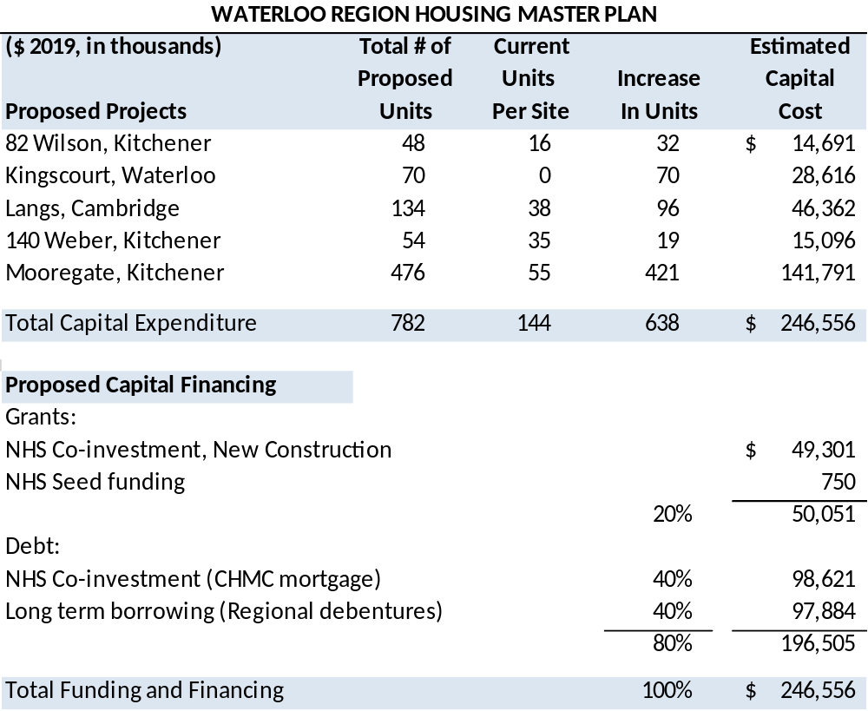

Proposed capital financing includes grants from the National Housing Strategy (NHS) Co-investment program for new construction and seed funding. This is a Federal program and the grant amount is contingent on program requirements being achieved. Based on the Master Plan assumptions, it is estimated that grant funding will be 20 per cent or $50M of the proposed total capital financing. These grants can be used for costs related to pre-development and construction activities.
The remaining funding sources consist of NHS Co-investment financing (CMHC mortgages - $99M) and Regional long term borrowing ($98M). Combined, these sources comprise approximatley 80 per cent of the estimated total capital costs. If Council approves the Plan as presented in this report, staff will incorporate the capital cost into the preliminary 2020-2029 Housing Capital Program, as set out in Appendix A. Appendix B provides a debt financing chart which depicts the estimated annual debt issuance that would total $196.5 million over the 11 years should the master plan be implemented as proposed.
- Proposed operating budget impacts
Operating revenues, expenses, and net levy impact have been estimated in 2019 dollars. Revenues include market, affordable, and RGI rents as well as non-rental revenues (e.g., laundry, parking income). Operating expenses include utilities, service contracts, other maintenance costs, insurance, lifecycle provision, and debt servicing based on the financing assumptions described above.
The incremental annualized tax levy impact by 2030 would be approximately $3.4M (0.6 per cent) as outlined in the table below.
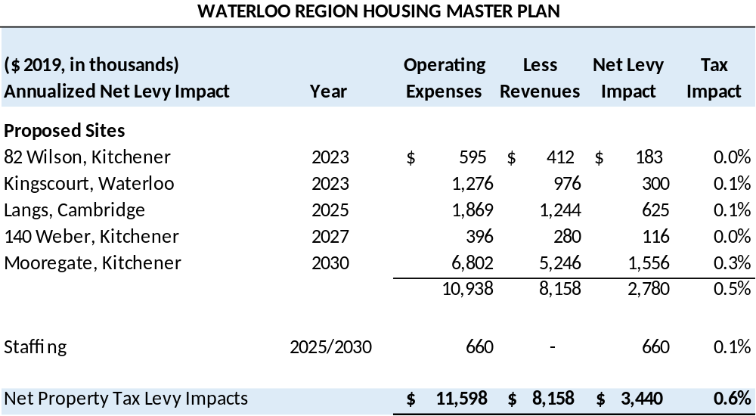

A projection of operating budget impact, which includes the estimated staffing costs, by site and annual levy impact is provided in Appendix C.
The figures in the previous table are based on the following long-term financing assumptions:
1) NHS Co-investment financing (which is effectively a mortgage issued by the Canada Mortgage and Housing Corporation) is potentially available for a 50 year term at a rate of 1.8% over the first 10 years. Interest rates would be subject to renewal for further 10 year terms. Additional research will be required with the CMHC and the province to ensure municipalities can access this funding.
2) Regional long-term borrowing has been projected based on a 30-year regional debenture issue.
Combined, this would result in an average borrowing term (taking into account the two sources above) of approximately 40 years. While this is a longer term than the Region would typically choose over which to finance asset construction (10 to 20 is standard), this approach does have the effect of keeping debt servicing costs lower and the net tax levy impact lower. On the downside, the overall amount of interest increases and the debt remains on the Region’s books for a longer period of time. The Region could issue its debt over a shorter term (i.e. 10 to 20 years), which would reduce the overall average life of the debt. The table below shows the net tax levy impact of the WRH master plan under different debt issuance scenarios:
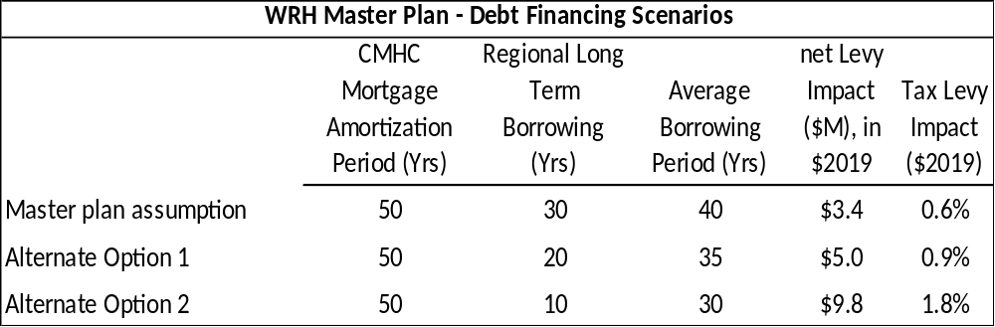
There are advantages and disadvantages to each scenario, as previously discussed. The decision with respect to which term to use would be made at the time that the debenture financing would be required for a given project.
- Proposed staffing
The completion of this strategy will require the addition of four FTE’s (two in WRH/Housing Services, two in Facilities Management) to deliver the revitalization program. These positions will be funded through a combination of the tax supported operating budget and a recovery from capital projects. A budget issue paper for the new positions will be prepared for consideration as part of the 2020 budget process.
The addition of 638 units will require seven permanent FTEs to be added in 2025 (3.5 FTE) and 2030 (3.5 FTE) to support the operation and management of the additional units. These positions will be funded through the annual property tax supported operating budget.

Other Department Consultations/Concurrence:
The Steering Committee has representation from Planning, Economic Development, Finance, Community Services, Facilities Management, and Legal services. The consultation included key stakeholders across Regional Divisions and Departments.

Attachments:
Attachment 1: The Waterloo Region Housing Master Plan (2020-2040)
Prepared By: Ryan Maharaj, Social Planning Associate
Ryan Pettipiere, Housing Director, Community Services
Approved By: Douglas Bartholomew-Saunders, Commissioner, Community Services
Appendix A: WRH Revitalization strategy
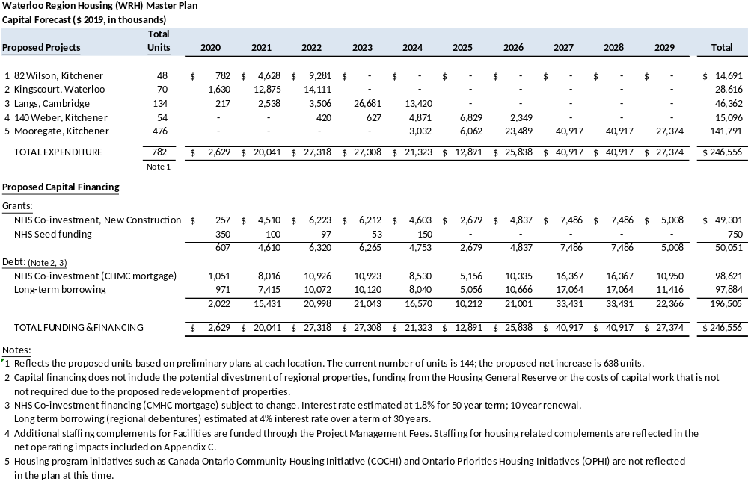
Appendix B: Debt Financing Chart
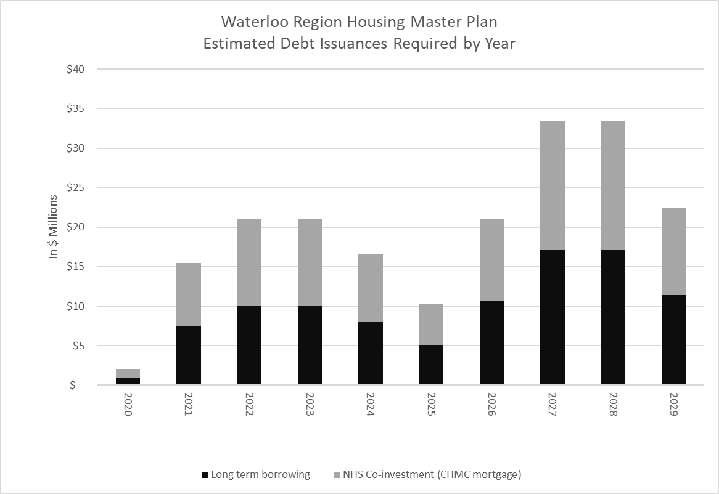
Appendix C: Total Projected Levy Impact

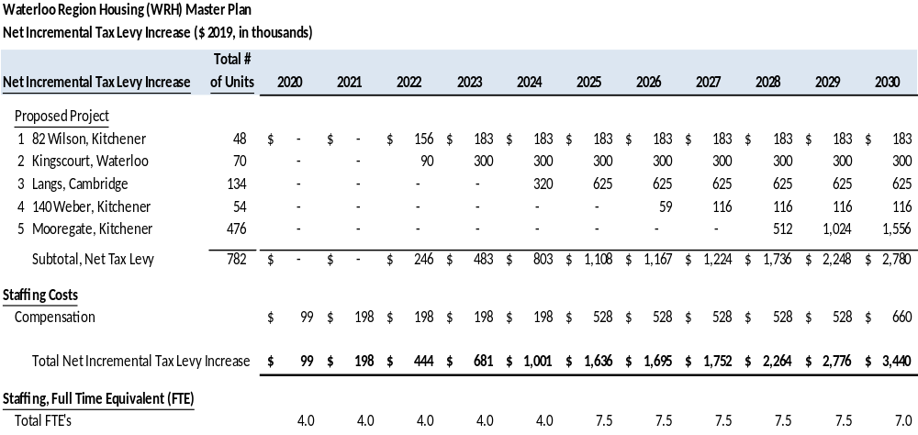

Appendix D: WRH Revitalization Strategy Proposed Project Timelines
